The tasks of solving the problem are listed below:
1) From the description, please define the acceptance criteria. The acceptance criteria should have the full coverage of the input domain with valid and invalid input and various kinds of valid inputs. For invalid input, a certain type of Exception should be thrown. The test case should include the test of throwing exceptions.
2) Apply Input Domain Modeling (IDM) techniques to fill in the table of program characteristics and block values for the method isBipartite(). Please include both interface and functionality-based IDM for defining characteristics. The table template is listed below.
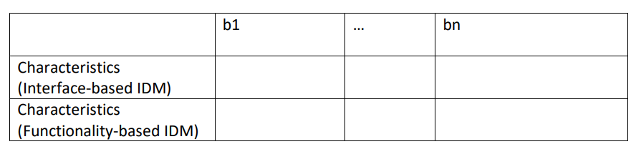
4) Apply Each Choice Coverage (ECC) and list the generated combination in Table 1.
5) Apply Basic Choice Coverage (BCC) and list the generated combination in Table 2.
6) Develop a test case for each cell of each table and fill the test case in Table 1 and Table 2. Save the values in two .csv files
7) Develop test functions in Junit 5 to retrieve the values of the test cases from the .csv files. For example, @ParameterizedTest and @CsvFileSource An example is given below.

